**ASSIGNMENT DATE-18-12-2023**

**Class & Objects**

* Classes are created by keyword class.
* Attributes are the variables that belong to a class.
* Attributes are always public and can be accessed using the dot (.) operator. Eg.: Myclass.Myattribute

**An object consists of:**

* **State:** It is represented by the attributes of an object. It also reflects the properties of an object.
* **Behavior:** It is represented by the methods of an object. It also reflects the response of an object to other objects.

**Identity:** It gives a unique name to an object and enables one object to interact with other objects.

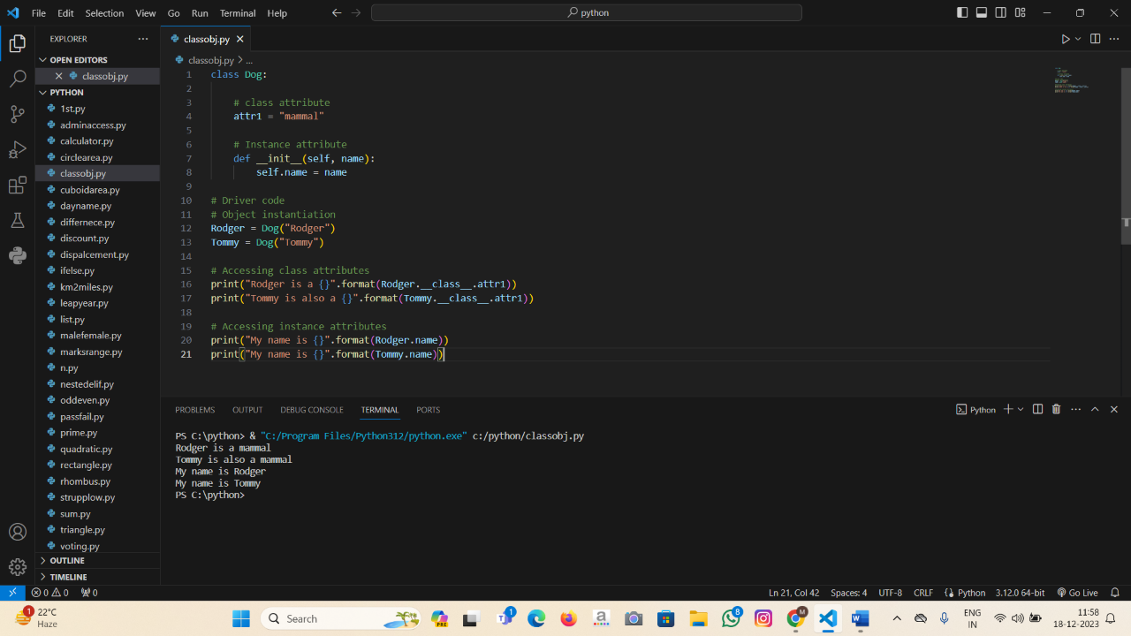

**Python Inheritance**

Inheritance is the capability of one class to derive or inherit the properties from another class.

**Types of Inheritance**

* **Single Inheritance:**  Single-level inheritance enables a derived class to inherit characteristics from a single-parent class.
* **Multilevel Inheritance:** Multi-level inheritance enables a derived class to inherit properties from an immediate parent class which in turn inherits properties from his parent class.
* **Hierarchical Inheritance:** Hierarchical-level inheritance enables more than one derived class to inherit properties from a parent class.
* **Multiple Inheritance:** Multiple-level inheritance enables one derived class to inherit properties from more than one base class.

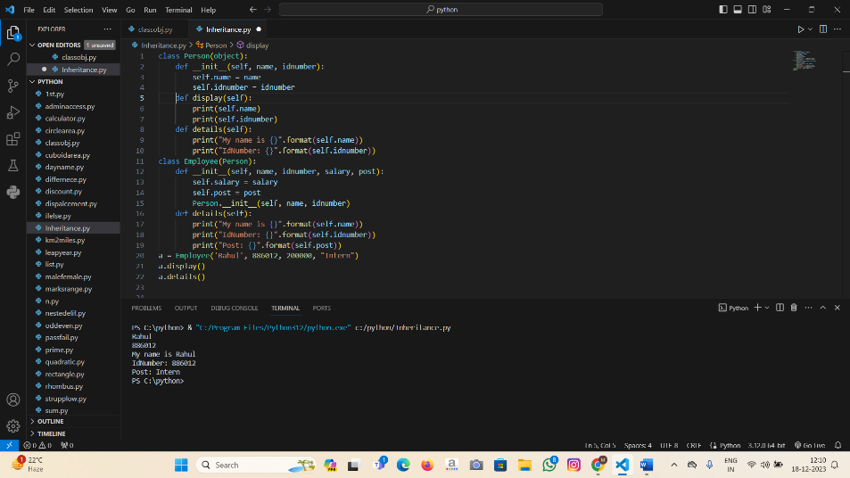

**Python Polymorphism**

Polymorphism simply means having many forms.

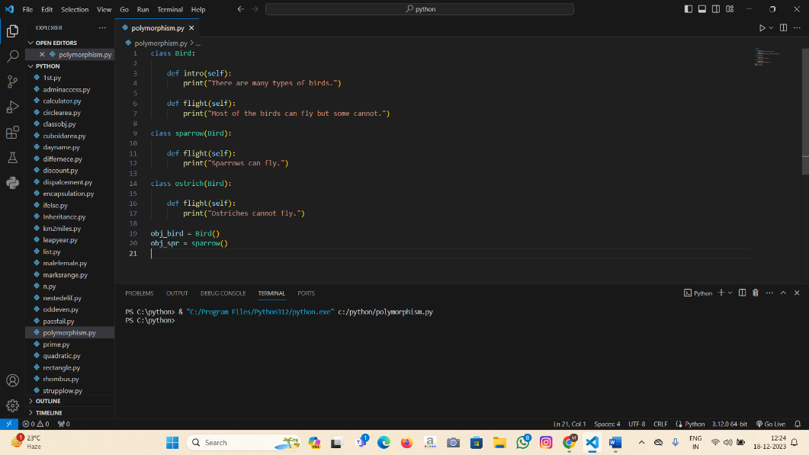

**Python Encapsulation**

Encapsulation is one of the fundamental concepts in object-oriented programming (OOP). It describes the idea of wrapping data and the methods that work on data within one unit. This puts restrictions on accessing variables and methods directly and can prevent the accidental modification of data.

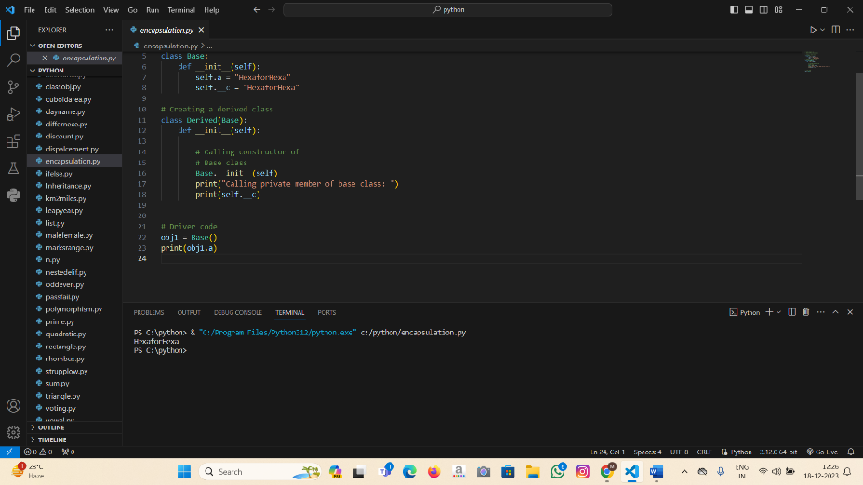

**Python Modules**

Modules are nothing but group of functions, variables and classes that are saved to a file.

There are 2 types of python modules:

1.Predefined

2.Userdefined

